Matthew Westcott
Bond University Student Association Website
../Assignment 2/index.html
Tutor: Dr. James Birt
8/6/2010

This website was designed from the pre-existing BUSA website at http://www.bondstudents.com/. A similar colour scheme was used, but I believe I’ve contrasted the colours together much better.

Website Analysis and Planning:

- Discuss the main objectives/aims of your website:
To help Bond students find clubs and facilities available at Bond University.
- List of Prioritised Objectives:
Item | Justification | Priority [1...5]
Sell a product or service | Trying to get more people to buy a SAM membership by explaining the benefits. | 1
To network | Helps the Bond University clubs and new students become acquainted. | 1
To serve your customers | We want to make the information easier to find than the previous website had been. | 2
To heighten public interest | This is a priority because we want to inform more people about the benefits of the Student Activity Membership scheme. | 2
To answer frequently asked questions | It is important to hear back from students to understand what their wants or needs are, a contact form was implemented as well as a contact phone number and address, to help students reach BUSA anyway they want to. | 1
To create 24 hr service | The BUSA website provides students with information on clubs and events all year round, hopefully the site will be updated frequently. | 3
To make changing information available quickly | Most information stays constant, but there certainly is the ability to update club information at any time with the new simplified layout. | 5
To allow feedback from customers | Contact form has been added and validation checks are in place to record names and email addresses. | 2
To reach new media | We have a link to the Facebook page from our website so students can easily interact with BUSA. | 3
Improve access to information | This is perhaps the only way (that I know of) to find information about Bond University clubs without finding the right person on campus. | 4

Website Details
Item | Description
Company/ Business Name/ Title | Bond University Student Association
Keywords that relate to your proposed site (these may be used as Meta Tags, Search Words by your viewers or as optimisation criteria) | bond, university, student, association, busa, clubs, gold, coast, australia, queensland, SAM, student, activities, membership, kung, fu, united, nations, soccer, it, faq, contact
Target Market(s) | Both students and non-students are able to participate in the clubs at Bond University. However the main focus will of course by the students.
Write a short description / summary of a visitor who represents your target market / client. | Students at Bond University and perhaps their friends who would like to participate in the clubs offered on campus.
What is the main information/focus you want the viewer to absorb when they click on your Home page? | We want visitors to become better informed about the clubs at Bond but we also want to encourage students to enrol into a Student Activities Membership.
Is this information actually what the visitor will want – if so Why? | Yes, if they’d like to join a club, they might find it beneficial to also obtain a Student Activities Membership.
After the Home page – where do you want them to click next – (preferred order) why? | Each visitor will have different needs, but perhaps ideally we’d like them to enquire about the Student Activities Membership, or perhaps they’d want to see if a SAM enrolment is worthwhile by checking out what clubs are available.
What have you included in the page design that gives the visitor visual or other clues - so they will know where you want them to go next? | We’ve made the navigation simple at the top of the page, so everything is found quickly.
Does the website have an existing logo?  If so what are its colours / theme.  If not: what type/style of logo would be appropriate (include colours/reasons) | I have used the Bond University logo and added the text “Student Association” underneath it and combined that into a Fireworks image, leaving plenty of white space to the right for an SWF movie. I used the website http://colorschemedesigner.com/ to choose my colours. 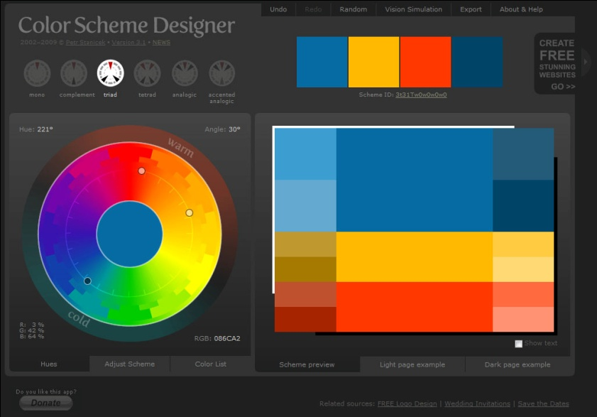  I was originally intending to use all three colours but found the blue and orange to work well enough alone, especially as it is the same colour as the Bond University logo. Blue gives a feeling of power, but also calmness, and I thought most people would find the colour scheme quite pleasing.

- 3 known competitors or comparison websites, with short critiques (no more than 1 page) for each – explain why you thought they were relevant

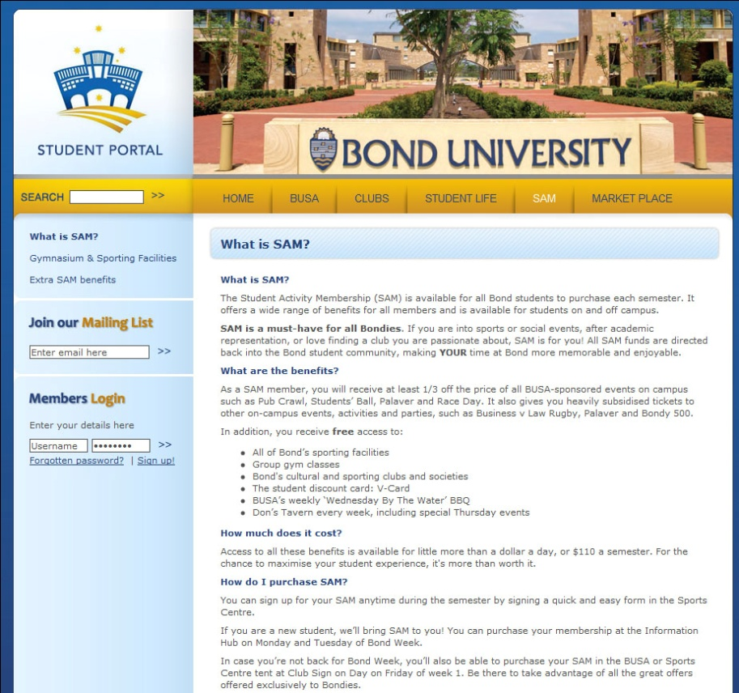
This first website is obviously relevant because it is the previous edition of the BUSA website. I liked the colour scheme they had chosen but decided that I could make a few tweaks to make it look a bit better.

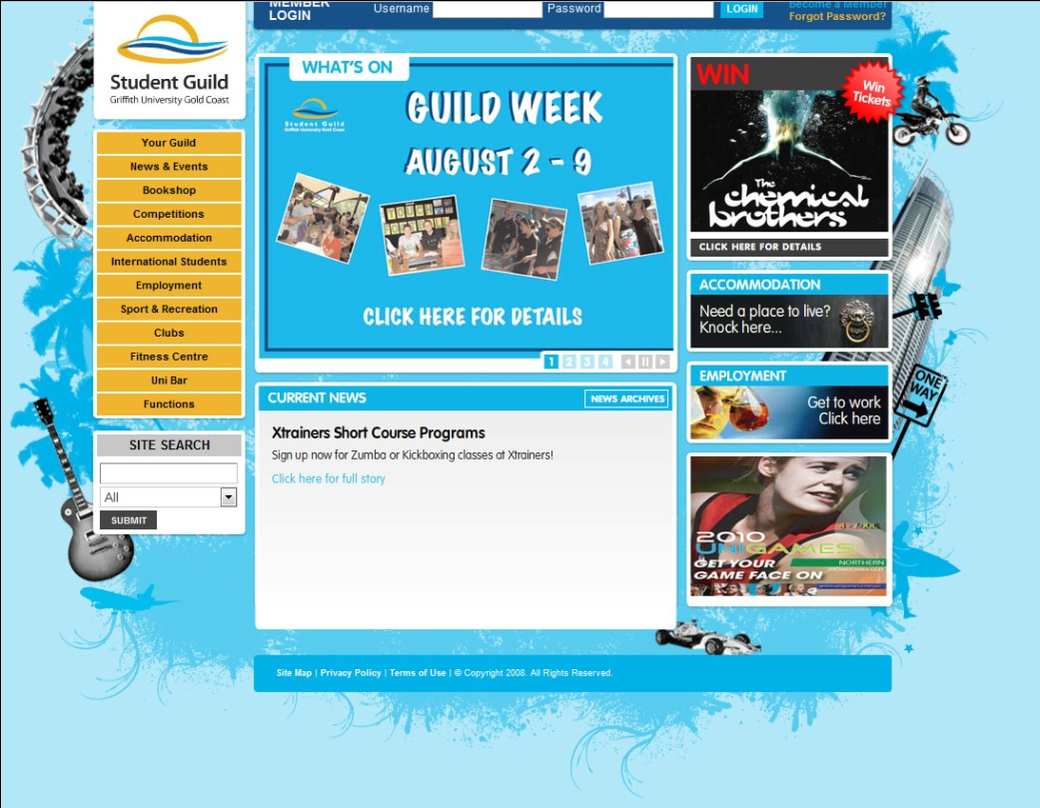

The Griffith Student Guild website also used similar colours, but functionally, it was a mess. Some text would be missing behind toolbars and the page would often take too long to load. By keeping things simple, I’ve learned that you can give your visitors the information they need without wasting their time loading too many flash apps.
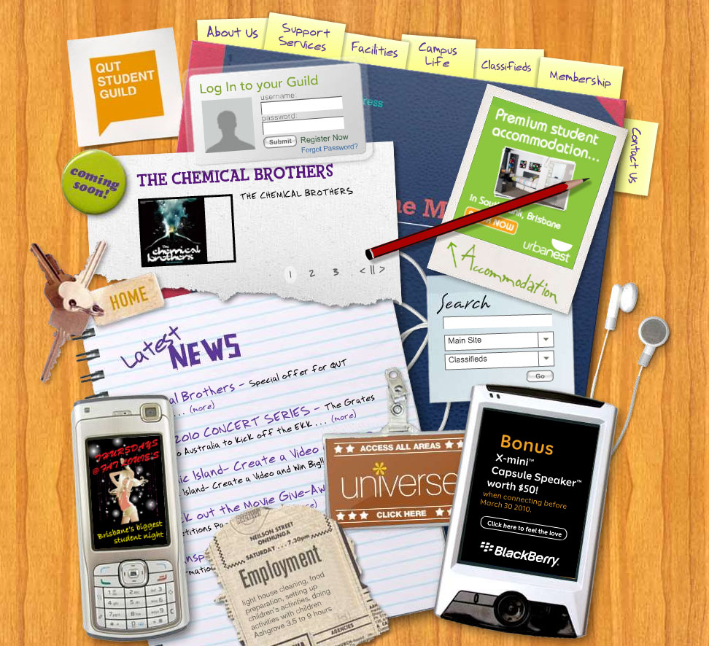
The QUT student guild website was full of junk, and I can understand how this design could be appealing to some, just looking at it gives me a headache, and that’s not what you want when you need to find specific information quickly.

- Completed Pages/with short description/ and file names
Page | Description | Filename
1 | Home Page | Index.html
2 | What is BUSA? | Busa.html
3 | SAM information | Sam.html
4 | Clubs information | Clubs.html
5 | FAQ | Faq.html
They are all fairly self-explanatory.

- Reference to any copyright images/content uses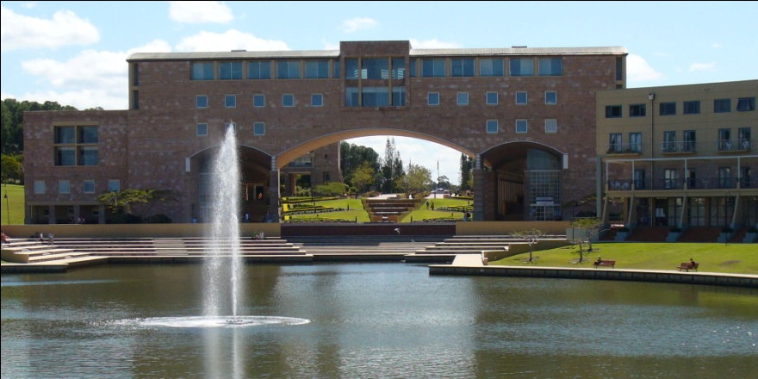
I used this image of Bond University for my flash video at the top of each page; I couldn’t find any copyright information however. The Bond University logo was also used.

TIME LOG
Date | Time | Description
 | 2 hours | Building and figuring out the flash video.
 | 3 hours | Brainstorming on the appropriate design and layout for the website.
 | 7 hours | Building the template for the site
 | 2 hours | Adding content (easiest part!)

Storyboards / Design Layouts / Wireframe
You must design and layout for each of your proposed pages. This should reflect the C.R.A.P principles.
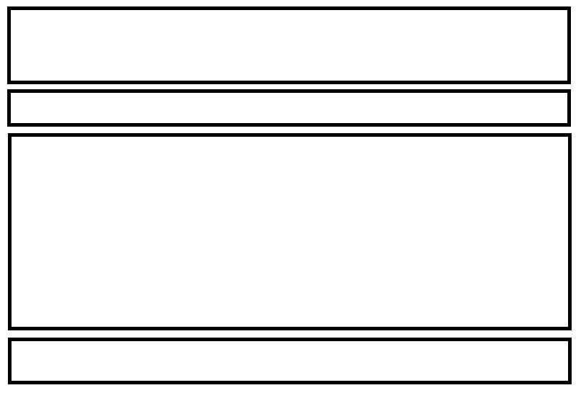
This time I decided against sidebars and opted for a more simplistic style, it actually turned out much better than I thought, as usually I’d always add a sidebar.
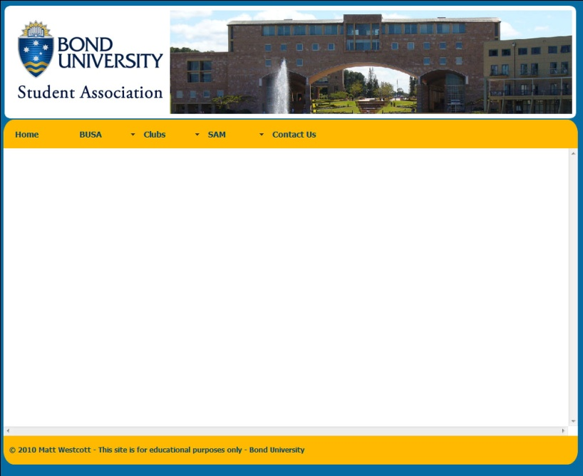
I’d like to have had 12 different page types to improve my mark here, but I only used the one template for every page (I guess I could say this is a good example of repetition in the C.R.A.P. principals!). I think the contrast between the background, the navbar and logo turned out much much better than I could have imagined. With the logo, I made sure to align the text “Student Association” perfectly with the left and right sides of the Bond University logo, while the flash movie sits snug to the right of it. I took quite a bit of time making sure the proximity of the text to the edges of the DIVs was just right. This is probably one of the best attempts at webs design I’ve done, I’m very happy with my efforts this time around!

